Ch03-Lab 3

# Task 1: Let's practice with strings

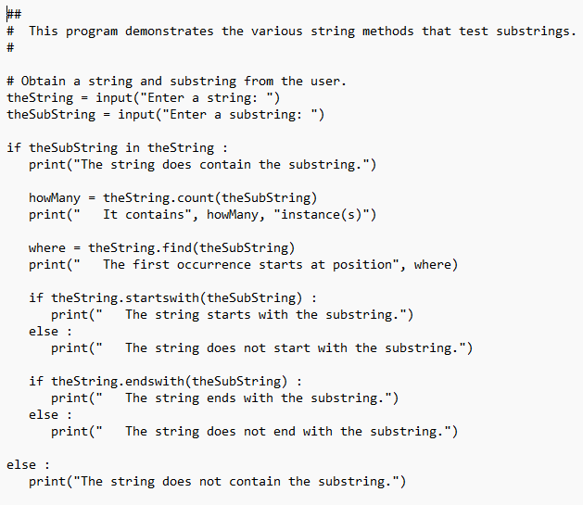

|  |
| --- |

|  |
| --- |

# Task 2

Given a string made up of different characters, identify whether the string is:

* + All letters
  + All digits
  + A mixture of letters and digits
  + A mixture of all (letters, digits, any other symbols)

# **Sample outputs:**









|  |
| --- |

|  |
| --- |

|  |
| --- |

|  |
| --- |

|  |
| --- |

# Task 3: Match statement

# *Write a program that asks the user to enter a month (1 for January, 2 for February, and so on) and then prints the number of days in the month. For February, print “28 or 29 days”.*

# *You must use a* ***match*** *statement in this program.*

# 

**Test your code 4 times for:**

**2,4,5, and 22**

**Sample output:**







|  |
| --- |

|  |
| --- |

# 